**Exercises to help you find your session Goal**

The purpose of these exercises is to help you find clarity on your goal for the session. Sometimes its easy to see what we need to talk about or work on. Other times it can feel muddy or difficult to see a way through. These can hopefully help find clarity. Remember that Coaching is about bridging the gap from the present (where you are now) to the future (where you want to be).

Use as many or as little as you need prior to the session. Please email the form to Georgia at [georgia@georgiageyerconsulting.com](mailto:georgia@georgiageyerconsulting.com) or bring the form to our first session.

### 

### **Life Wheel**

Rate your level of satisfaction for each area on a scale of 1-10, where 10 is the greatest satisfaction. Fill in the slice from the center outward based on your rating, (e.g. for a rating of 5 fill in the slice from the center outward halfway)

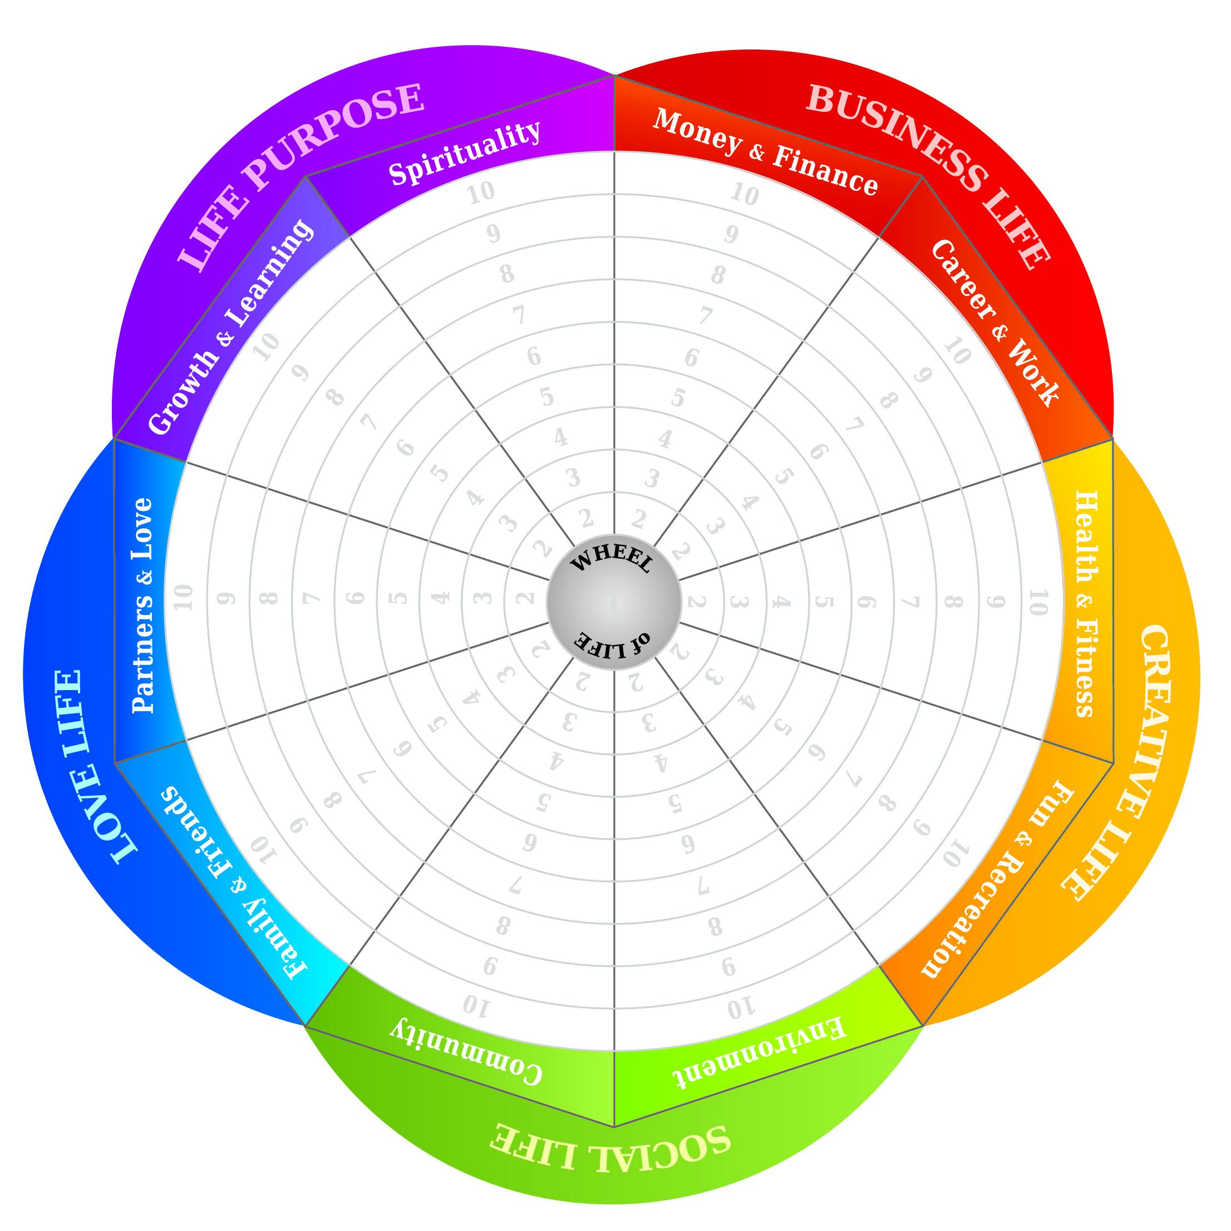

### **Wish List**

Please complete the following wish list by putting a check mark next to each item of interest. Check as many boxes as you like.

I would like to become more:

* Social
* Intellectual
* Productive
* Service-Oriented
* Involved in the Community
* Fun-Loving
* Well-Read
* Educated
* Well-Traveled
* Skilled
* Creative
* Artistic
* Physically Active
* Family-Oriented
* Thoughtful
* Giving
* Spiritual
* Relaxed
* Happy
* Goal-Oriented
* Religious
* Playful
* Financially Prosperous
* Healthy
* Independent
* Knowledgeable about ________
* Involved in a new relationship
* Involved in an Organization
* Involved in ______________

What I’d most like to explore: ____________________________________

_________________________________________________________________

### 

### 

### 

### **The 5 Ways I Would Like to Grow in the Next Year**

1. ____________________________________________________________________________________________________________________________________________________________________________________
2. ____________________________________________________________________________________________________________________________________________________________________________________
3. ____________________________________________________________________________________________________________________________________________________________________________________
4. ____________________________________________________________________________________________________________________________________________________________________________________
5. ____________________________________________________________________________________________________________________________________________________________________________________

### **Client Priorities**

Write one sentence for each.

I’d like to change my life in the following areas:

1. ____________________________________________________________________________________________________________________________
2. ____________________________________________________________________________________________________________________________
3. ____________________________________________________________________________________________________________________________

I want to improve my skills in the following areas:

1. ____________________________________________________________________________________________________________________________
2. ____________________________________________________________________________________________________________________________
3. ____________________________________________________________________________________________________________________________